Vivara Franchise Modeling Report – Case Study: Feasibility of a Public-Private Partnership (PPP)

Project: Luxury Commercial Concession – Vivara Store – PPP Barra/Graça/Vitória

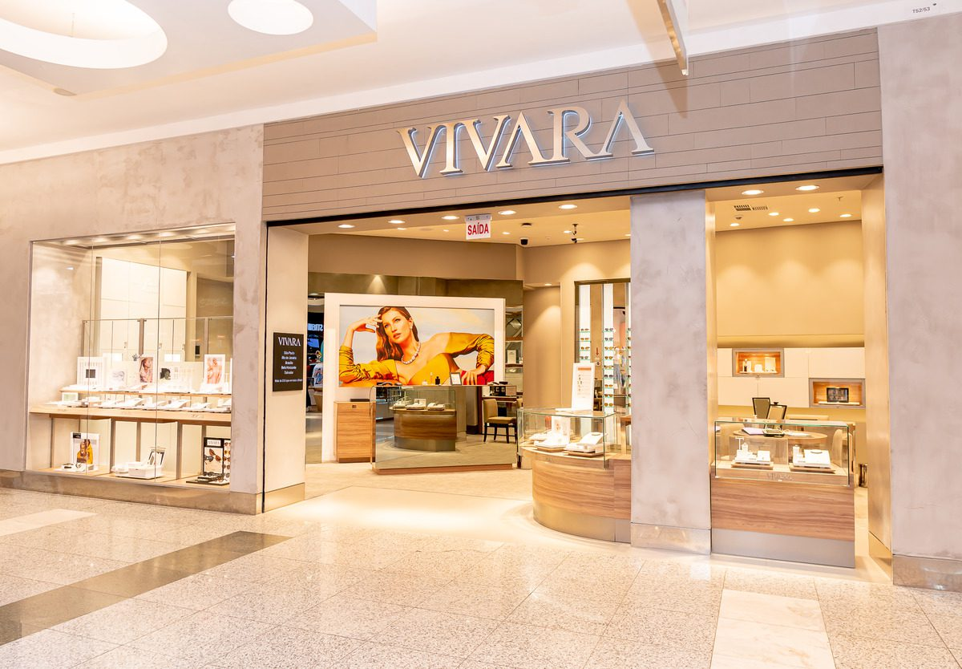

1. Choice of Business, Location, and Justification for the PPP

The Business: Implementation of a high-end jewelry and watch street store modeled on Vivara (VIVA3).

The Location: Public space in the Barra/Graça/Vitória region, Salvador – BA.

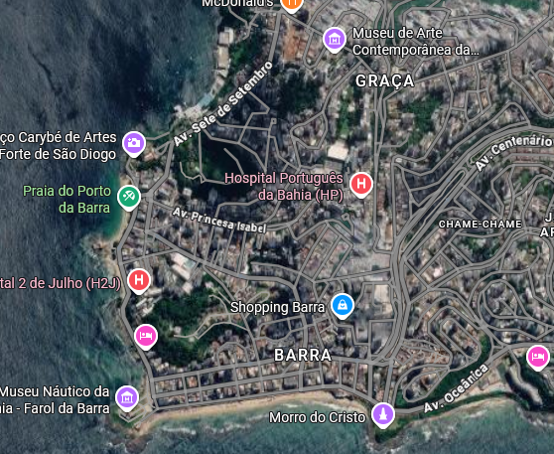
The Business Model: High-End Jewelry (Benchmark: VIVA3)
The chosen business consists of the implementation and operation of a high-end jewelry and watchmaking concept kiosk/pavilion, structured along the operational lines of Vivara (B3: VIVA3). The choice of this segment in physical retail is justified by the excellent ratio between the square meters occupied and the high Average Ticket Value (ATV) of the merchandise. Unlike food or clothing operations, jewelry requires a smaller physical space (lower civil construction cost and lower spatial impact on the public area) and does not generate organic waste, odors, or noise pollution. It is a “clean”, high-value-added operation with high gross margins, allowing the financial sustainability of the business even with the incidence of the public concession costs.
1.2. The Strategic Location: Barra/Graça/Vitória Axis (Salvador – BA)
The project will be installed in a prominent public space in the Barra, Graça, or Vitória Corridor area (such as the surroundings of Largo da Vitória or the Farol da Barra boardwalk). The choice of this macro-region is based on three economic pillars:
- Income Density: The region concentrates one of the highest Human Development Indices (HDI) and the highest per capita income in the Bahian capital, housing the primary consumer base for luxury goods.
- Premium Tourist Flow: The location is a natural postcard, guaranteeing a continuous flow of national and international tourists with a high propensity to consume commemorative and luxury items.
- Brand Visibility and Positioning: Installing a boutique in a postcard location provides invaluable organic marketing exposure for the brand, associating luxury with the natural and historical beauty of Salvador.

1.3. Target Audience and Attractiveness Potential
The target audience is predominantly composed of classes A and B, encompassing local residents with high purchasing power and leisure or business tourists. Local demand is justified by the convenience and exclusivity of the experience: buying a piece of jewelry in a historic, scenically beautiful setting, outside the closed and standardized environment of shopping malls. The attractiveness potential is based on “qualified impulse purchases” and gift purchases, boosted by the high pedestrian flow in the surrounding area on weekends and holidays.
1.4. Justification and Structuring of the Public-Private Partnership (PPP)
This is a fee-based concession for the use of public space. The private operation finances the maintenance and integrated security of the surrounding public space, relieving the municipal budget and boosting local tourism through a fixed percentage transfer set at 5% of gross revenue, allocated exclusively to the conservation and patrolling fund for the location.

The Private Side: The investor gains the right to commercially exploit a location with extremely high foot traffic and zoning restrictions (where competitors cannot easily establish themselves), guaranteeing a temporary “economic moat” (competitive advantage).
The Public Side (The Counterpart): In exchange for permission to use the land, the project provides for a monthly transfer – structured as a fixed percentage of 5% of gross revenue – allocated to a fund for the conservation and security of the location.
Positive Externalities: These funds will directly finance landscaping maintenance, cleaning, and, primarily, the security of the immediate surroundings. This generates a formidable positive externality: the operation shields the jewelry store against theft, while at the same time giving the people of Salvador a safer, better-lit, and better-maintained square, boosting tourism and property values in the region without burdening municipal coffers.

2. Assumptions Considered in the Project and Operational Premises

For the composition of revenues and costs, the following market assumptions were adopted, adapted from the average performance per point of sale:

Flow and Conversion (Weekly Estimate):

Weekday: Expected 1,200 visitors/day in the surrounding area; estimated conversion rate of 1.5%; average ticket of **R$ 1,150.00.
Saturday: Expected 2,500 visitors/day in the surrounding area; estimated conversion rate of 2.0%; average ticket of **R$ 1,300.00**.
Sunday/Holiday: Expected **2,000** visitors/day in the surrounding area; estimated conversion rate of **1.2%**; average ticket of **R$ 1,050.00**.

Tax Regime: Actual Profit (effective rate of deductions and taxes on revenue of 20.3%, per the consolidated Income Statement).

Partnership Cost (PPP Concession Fee): Transfer of 5.0% of monthly Gross Revenue allocated to the maintenance of the public space and integrated monitoring.

Discount Rate (MARR/WACC): Set at 15.4% per year for calculating the NPV and discounting the cash flow.

3. Income Statement (Projected Monthly)

Summarized Income Statement Line | % of Gross Rev.
(=) GROSS OPERATING REVENUE | 100.0%
(-) Deductions and Taxes Incurred | 20.3%
(-) PPP Transfer (Barra/Graça Maintenance Concession) | 5.0%
(=) NET OPERATING REVENUE | 74.7%

(-) Variable Costs (COGS – Jewelry/Supplies) | 24.1%
(-) Fixed Operating Costs (Personnel, Utilities, Base Security) | 26.3%
(-) Administrative/General Expenses | 8.9%
(=) NET OPERATING RESULT (EBIT/PROFIT) | 15.4%

4. Investment Structure (CAPEX and Working Capital)

CAPEX (Initial Investment – Physical):

* Infrastructure (Premium boutique, security reinforcement, display cases): R$ 450,000.00
* Equipment, IT, Alarm and Monitoring Systems: R$ 250,000.00
* Licenses, Municipal Fees, Legal Costs: R$ 92,707.32
* TOTAL CAPEX: R$ 792,707.32

Initial Working Capital:
* Initial Inventory (Stock of high-value gold and silver jewelry): R$ 1,250,000.00
* Operating Reserve (First months of fixed expenses): R$ 233,192.68
* TOTAL WORKING CAPITAL: R$ 1,483,192.68

*Note: The total implementation investment in Year 0 consolidates an outflow of R$ 2,275,900.00*

5. Projected Operating Cash Flow

(Projection based on the Expected Scenario from the Valuation Summary)

Period 0 (Initial Investment):
CAPEX + Total Working Capital: R$ (2,275,900.00)
Total Cash Flow in Period 0: R$ (2,275,900.00)

Annual Net Cash Flows (Year 1 to Year 4):

- Year 1: R$ 312,800.00
- Year 2: R$ 688,400.00
- Year 3: R$ 1,136,300.00
- Year 4: R$ 1,250,300.00

6. Financial Indicators and Sensitivity Analysis

Project Indicators (Base Scenario – Expected):

- NPV (Net Present Value): R$6,220,100.00 (The project generates strong value creation beyond the 15.4% MARR).
- IRR (Internal Rate of Return): 57.8%
- Discounted Payback: 4.0 years (48 months)

Sensitivity Analysis (Extremes):

- Optimistic Scenario: NPV of R$ 7,931,000.00 | IRR of 62.7%.
- Pessimistic Scenario: NPV of R$ 4,685,800.00 | IRR of 51.7%.

7. Associated Risks and Mitigations

Public Safety Risk: mitigated through the PPP counterpart contribution (5% of revenue). The investment subsidizes overt private security and 24-hour monitoring integrated with the Military Police's COPOM (command and control center), creating a relatively secure perimeter in Barra/Graça/Vitória.

Demand Risk: Mitigated by the strategic positioning (tourist circuit and high-end residential area) and by the resilience of high-income consumers to adverse economic cycles.

Inventory (Turnover) Risk: The capital tied up in inventory (representing the largest share of the initial investment) has inherent mitigation due to the nature of the assets (gold and precious stones), which act as a store of value against inflationary pressures.

8. Final Feasibility Assessment

Based on the economic indicators calculated under the Normal Scenario, the jewelry store implementation project in the Barra/Graça Region is presented as FINANCIALLY VIABLE. The Net Present Value (NPV) came to R$ 6,220,100.00, accompanied by an Internal Rate of Return (IRR) of 57.8%, comfortably exceeding the Minimum Attractive Rate of Return (15.4%) stipulated for the sector. The capital recovery time (discounted payback) of 48 months demonstrates a safe return, fully consistent with the entry barriers and inventory risk of the luxury market. Additionally, the Public-Private Partnership model proved sustainable, given that the operation supports the 5% transfer of gross revenue for the conservation and security of the public space without compromising the unit's free cash flow (FCF) generation.

